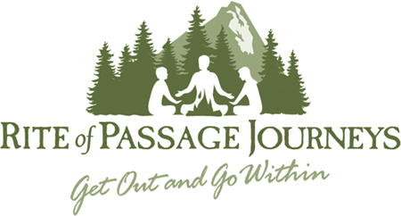
A letter from your guides

You walking, your footprints are
The road, and nothing else;
There is no road, walker,
You make the road by walking.
By walking you make the road,
And when you look backward,
You see the path you
Never will step on again.
Walker, there is no road,
Only wind trails in the sea.

Antonio Machado

Welcome, we are excited to meet you at this point in your journey. By applying, you have stepped across a threshold, said “Yes” to a calling. As your guides on this particular stretch of the road, we are leaning in and listening, curious to know more about who has arrived at this waypoint.

We invite you to let the trembling of your heart be heard. Let yourself be stirred. Let the playful and the terrible come through. Let this be an opportunity to encounter yourself for the first time again. Imagine that this is a conversation between you and You, or you and….. Allow yourself to be surprised. Here, all voices, all parts are welcome.

This application is the first of many steps that you may take on your way to the Quest itself. As your guides, we are responsible for the physical and emotional safety of you as individuals and for the group as a whole. Due to the challenges of this kind of ordeal (physical, emotional and otherwise), we take seriously the importance of properly screening and preparing each participant. While questing is a birthright for everyone, it is important that it comes at the right time in your life: one which is the union of ripe timing and strong internal resources. For some of you, that may mean that questing this summer is appropriate, for others the application process and conversations that emerge from it are stepping stones that may include a quest at a future time.

So, have at it Walker. We are excited to meet you…

Andrew and Sheryl
Adult Wilderness Quest Application

Adult Quest Application

Name:

Birthdate:

Phone Number:

Email Address:

Please respond to the following questions. Please be brief, getting to the heart of the matter, but take the space you need to do this well. This skill and these questions may foreshadow things to come.

What has drawn you to quest at this time, and how do you know you are ready?

Describe your personal experience with questing, soul work, ceremonial healing, and related practices. Please list organizations/facilitators, personal practices, dates, and anything else that you may feel that would reflect your journey.

Have you experienced a life crisis that pushed your limits, from which you discovered more about yourself, the world at large, and your place and direction within it? Please share timing and the nature of your experience.

How would you describe yourself in terms of roles you hold, archetypes that move through you, mythic images that seem to hold power for you?

Please take the time to share about your mental health history, anything that you feel will help your guides support you and the group field; including information related to psychotherapy or healing services received (dates/modalities); symptoms experienced; historical traumas; hospitalizations; struggles with suicide and self harm, etc. Additionally, humans through nature’s design, have developed addictive and dissociative capacities. These many include but are not limited to controlled substances/alcohol, screen time, social media, shopping, food, staying busy, and countless other means of distraction. Please explore and list any addictions or dissociative behaviors that you might have.

Healing modalities (EMDR, psychotherapy, CBT, DBT, shamanic healing, mindfullness practices, etc:

Symptoms:

Addictions:

What are your triggers and challenges interpersonally? Intra-personally?

What has come up for you in the course of writing this application?

